**Q12. Weather Observation Station 7**

Query the list of CITY names ending with vowels (a, e, i, o, u) from STATION. Your result cannot contain duplicates.

The STATION table is described as follows: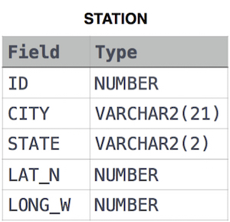

Ans.

SELECT DISTINCT(CITY)

FROM STATION

WHERE LOWER(CITY) LIKE '%a' or LOWER(CITY) LIKE '%e' OR LOWER(CITY) LIKE '%i' OR LOWER(CITY) LIKE '%o' OR LOWER(CITY) LIKE '%u'

**OR**

SELECT DISTINCT(CITY)

FROM STATION

WHERE LOWER(CITY) REGEXP '[AEIOU]$'